Process Owner

  - Triumph Group Supply Chain Management

Applies To

  - Triumph Group Supply Chain Management, Triumph Group Supplier Quality Management and Triumph Operating Companies.

Purpose
  - Document the Enterprise process and in which TGI and our third parties establish a continuous improvement environment utilizing Lean and Six Sigma tools to improve cost, quality and delivery.

Reference Documents

  - SCMP 2.1 - Supplier Corrective Action
  - SCMP 2.2 - Supplier Performance Improvement Program
  - SCMP 3.3 - Supplier Capability Assessment
  - SCMP 5.2 - Supplier Performance Measurement
  - SCMP 7.4 - Sourcing Board Supplier Selection
  - SCMP 7.5 - Work Transfer
  - SCMP 8.1 - Supplier Product Conformity Assessments
  - SCMP 9.2 - Delivery Assurance

Definitions and Acronyms

  - SCLT - Supply Chain Leadership Team
  - SCM - Supply Chain Management
  - SD - Supplier Development
  - SDS - Supplier Development Specialist
  - SDM - Supplier Development Management
  - SQE - Supplier Quality Engineer
  - Activity- SD Project, SCMP 3.3 Supplier Assessment (b or d) or SCMP 9.2 Delivery Assurance
  - Supplier Development Project- Lean or Six Sigma Project designed to improve process, performance, quality or productivity.

Responsibilities

  - It is the responsibility of the buyer, commodity manager, SQE or SCM representative to initiate a request for SDS assistance. The supplier development management (SDM) team and stakeholders will meet on an as needed basis to review and prioritize the request(s) and determine appropriate resources (enterprise, operating company, regional office, third party). The buyer or SDS will contact the supplier to coordinate a supplier development Activity. The SDS resource will then collect all pre-work and consult with all appropriate resources. The SDS will then conduct the Activity at the supplier’s facility or virtually. Upon successful completion SDS will report out to the SDM team and stakeholders.

Procedure
  - Supplier Development Request
    - The requesting Triumph Company shall complete the Supplier Development Form on the Triumph Group Enterprise Supply Chain SharePoint or by requesting through Supplier Development group. The request must include:

Title (brief description)

Date Requested

Operating Company

Supplier TA# (or name if TA# is n/a)

Supplier Contact

Supplier Contact Phone #

Supplier Contact E-mail Address

Issue Type (Delivery Delay, Sourcing Board Request, Commodity Strategy Request, Customer Request or SCMP 3.3 On-Site Audit Request)

Triumph Contact Name

Triumph Contact Phone

Description of Situation (potential project scope)

Program Name

Description of Request; issues/impact to the business or a justification for Supplier Development engagement (i.e., Critical Component, Long Lead Time, High Volume, Directed Source Sole Source, etc.)

Deliverables/Expectations

    - Identify the Issue/Trigger event; Delivery Delay, Quality Issue/Escape, Sourcing Board Request, Commodity Strategy Request or Customer Request.

    - Requests may also include Supplier Commodity, Part Number and Part Revision Level, Purchase Order Details and Quantity Affected, Supporting Documentation as Required (i.e., define any e-SCARs, SIRs, e-SIRs and/or SPIPs issued, Open Order Reports, etc.)

    - The Request will be compiled into a database and an acknowledgement of the request will be provided to the originator within one business day.

  - Supplier Development Request Response
    - The SDM shall prioritize the Request List utilizing the data provided on the Supplier Development Request Form and Stakeholders inputs. Based on but not limited to impacts to programs, production, customer, and other business considerations.

    - The SDM may use the following for criteria to Evaluate/Prioritize Supplier Development Requests:

Triumph Companies currently doing business with the supplier (Stakeholders)

Enterprise Spend with the supplier

Supplier’s 12 Month Quality Yield

Supplier’s 12 Month On-Time Delivery

Previous SD Projects completed with the supplier

    - Identify appropriate resources

    - Define initial Project Scope, SCMP 3.3 Capability Assessment, Capacity Analysis, Quality event/support or Delivery Assurance support.

    - Assign Priority Activities to a Supplier Development Specialist/Lead

  - Supplier Development Specialist
    - Conduct the SCMP 3.3 Assessment, define the baseline for each Project from the data and complete the SD Project Charter or appropriate Delivery Assurance activities.

    - The SDS shall identify any special skills or resource for each Activity assigned to them and communicate to the SDM

    - The SDS shall inform the SQE when engaging a supplier for an SD Activity if the request is quality related.

    - Procurement or SDS must obtain the supplier’s buy-in for each Activity If the supplier rejects the invitation, then Procurement or SDS shall escalated the rejection to the SDM for action/response.

    - The SDS must contact the supplier and provide the following:

Agenda for the Activity

SD Toolsets to be utilized for the Activity, the SD toolsets and standard work guidelines can be found on the Triumph Group Enterprise Supply Chain SharePoint site.

SDS may request the supplier provide a SCMP 3.3 Capability Assessment or other self-assessment using the SD Tools provided.

    - The SDS shall provide the supplier an In-brief that includes Activity, Scope, Baseline and any assumptions.

    - If the Activity is a SD Project, SDS shall evaluate the Project Scope with the supplier, if necessary, the SDS will amend the Project Scope and/or reset the Baseline.

    - If the required skills or resources are not available to complete the redefined Project Scope the SDS shall escalate to the SDM for action/response

    - During the Project event the SDS shall record:

Findings and initiate an e-SCAR for each by contacting the appropriate organization.

Lessons Learned

Benchmark opportunities

SD Tools used and results

    - The SDE shall conduct an out brief for each Project with the supplier that includes:

SD Project Storyboard

SD Tools used and results

Observation

Findings Note: Findings are both positive and negative results

    - The SDS shall provide the SD Project results to the SDM and all identified stakeholders

    - SD Project records shall be archived in SharePoint

Appendices and/or Flowcharts

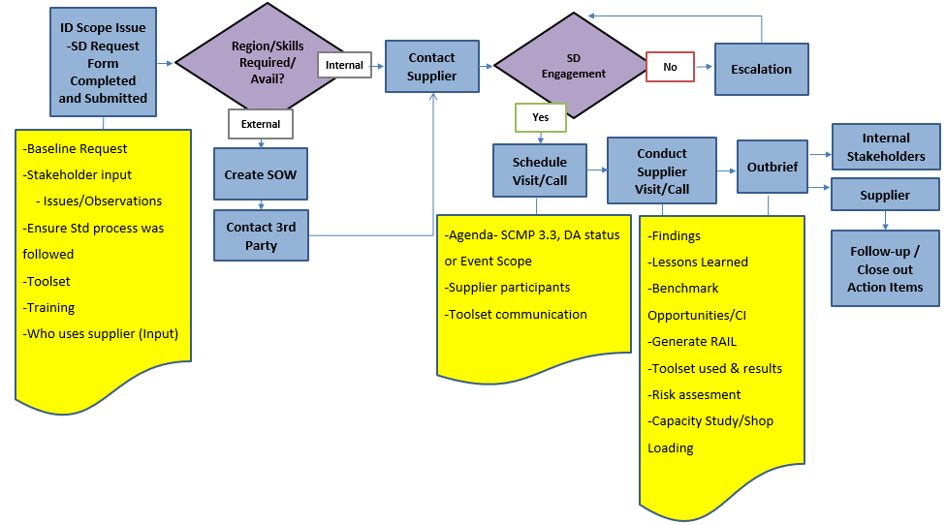

Supplier Development DMAIC Toolbox
  - The SDE shall have available a set of DMAIC Tools to utilize with the Supplier to help with Supplier Engagement and problem identification and resolution. Tools are located on the Triumph Group Intranet Site: Supplier Development Tool Box

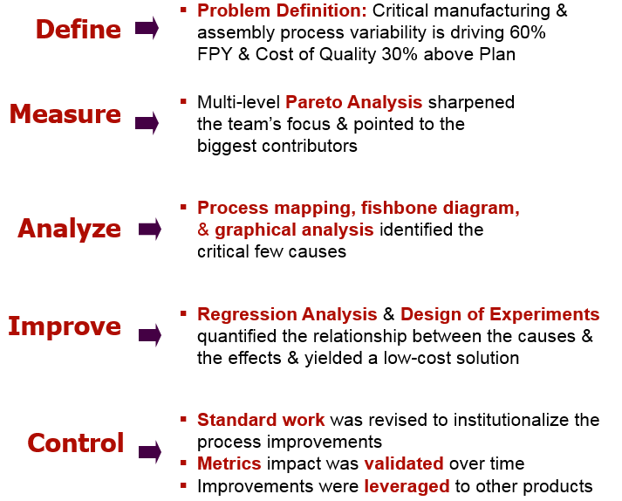

  - Risk Assessment /Rate Readiness
    - SCMP 3.3(aa) - Supplier Capability Risk Assessment and Tools

Training Document- Link

SCMP 9.1 Training

Revision History

Revision Level | Description of Change | Effective Date
Original | New Document  A  Add | 30 January 2018
A | References-Added 9.2. Definitions- Added Activity and Supplier Development Project, 7.1.1 Remove: or by requesting through Supplier Development email and revised required input into Request Form Requirements, 7.2- Revised optional inputs to decision and options used to address requests 7.3.5.2 Add: Standard work Guidelines, 7.4 Removed Quarterly Review requirement, updated flowchart, removed out-dated RACI, Updated training link | 01 December 2020
B | Clarification added for quality related issues  Revised/simplified flow chart  Replacement of reference to Business Units with Operation Companies  Replacement of references to SDE (Supplier Development Engineers) with SDS (Supplier Development Specialists) | 13 January 2021

- Approvals (Authorizing Signatures on File)
Director, Supplier Development, Triumph Group

