AS9100 Linkage: AS9100 Section 8.4 Purchasing Process

Supersedes

Revision D

Process Owner

  - Triumph Supply Chain

Applies To

  - Triumph Supply Chain Management, Triumph Supplier Quality Management and Triumph Operating Companies as noted in the Triumph Supplier Quality Assurance Manual. This document supports government and non-government procurements.
Note: The release of this procedure and the noted effectivity is the minimum requirement for sourcing that all Triumph Companies must immediately comply.

Purpose

  - To establish policies and guidelines for authorization of procurement action for purchased commodities, both new or those changing from the current source of supply.

Reference Documents

  - SCMP 3.3 – Supplier Capability Assessment
  - SCMP 4.1 – Preferred Performer Program
  - SCMP 5.1 - Triumph Approved Supplier List Management
  - SCMP 7.4 (a) Sourcing Project Preliminary Checklist
  - SCMP 7.4 (b) Pre-solicitation Review Sample Template
  - SCMP 7.4 (c) Source Selection Review Sample Template
  - SCMP 7.4 (d) Negotiation Plan & Agreement Scorecard Calculator
  - SCMP 7.4 (e) RAIL
  - SCMP 7.4 (f) Project Part Information Template
  - SCMP 7.5 - Work Transfer
  - SCMP 7.6 – Commodity Strategy Development

Definitions and Acronyms

  - AA Adoption Agreement
  - CMPT Cost Management Project Tracker
  - ESA Enterprise Sourcing Agreement
  - OpCo Operating Company
  - PRB Project Review Board
  - PSR Pre-solicitation Review
  - RAIL Rolling Action Item List
  - RFQ Request for Quote
  - SB Sourcing Board
  - SR Stakeholder Review
  - SSR Source Selection Review

- Responsibilities and Procedure

The PRB is the standing committee established for the review and approval of sourcing recommendations and captures actions during the RFQ process and following source selection. Attachment A describes the PRB application requirements. The Project Leader will determine PRB (SR, PSB or SSB) membership on a case-by-case basis using the charts in Attachment A and may invite other personnel to attend for advice or expertise in making final decisions.

This procedure documents the following processes:

  - Stakeholder Review
  - Pre-Solicitation Board
  - Source Selection Board
  - Negotiation Plan
  - Agreement Scorecard
  - Agreement Summary
  - Stakeholder Review
The purpose of this review is to collect details regarding a new or resourcing opportunity to relevant stakeholders. The project will be assigned a project number by addition to the CMPT, and a Project folder will be allocated on the Strategic Sourcing SharePoint site. The deliverable of this stage is the 7.4 (a) Preliminary Project Risk Assessment and the initiation of a SCMP 7.4 (e) RAIL. This will provide inputs to aid in the development of a PSR. Upon this initial review and analysis of the Project, if the criteria defined in SCMP 7.4 (a) are not met, the Sourcing Project shall not be progressed until closure, or planned closure, of all open actions. The Project Leader (in conjunction with the Stakeholder Review project team) will determine if the project is to move to PSR.
Note: SR is not required for a contract

Responsibilities and Procedure, Continued
  - Pre-solicitation Review
    - Upon completion of an SR, the Project Leader will prepare the subsequent PSR presentation.
    - Once created, the Project Leader will present the PSR to management per Attachment A, using scheduled recurring meetings.
    - Following completion of the PSR management review, the Project Leader will send the presentation to the SB members per Attachment A, using Outlook voting buttons.
NOTE: Electronic signatures (e.g., email) are acceptable.
    - SB members will review and approve presentation material and return to the Project Leader within five (5) business days, including any recommendations for specific changes and requests for resubmittal.
NOTE: No response within the 5 business days will be considered approval.
    - The Project Leader will summarize PSR proceedings and conclusions and execute actions approved in the PSR and capture any actions in the RAIL SCMP 7.4 (e).
- Note: the requirement for all suppliers to support the Triumph Work Transfer Process SCMP 7.5 must be included in all RFQ bids
    - Any Enterprise, OpCo or Site-specific documentation should be addressed by the responsible parties, as necessary.

Note: PSR Template is not required for a contract

Responsibilities and Procedure, Continued
  - Source Selection Review
    - Upon receipt of bids or completion of agreement negotiations, the Project Leader will develop the SSR presentation. This will include cost analysis using the templates in supporting documents.
NOTE: It shall be acceptable to utilize alternative cost analysis templates on a case-by-case basis as determined by the Project Leader
    - The Project Leader will present the SSR to the SB members per Attachment A, using scheduled recurring meetings.
NOTE: It is recommended that the Project Leader send the SSR presentation to the SB members 24 hours in advance of the SB.
    - After presenting the SSR, the Project Leader will send the presentation to the SB members per Attachment A, and document approval using Outlook voting buttons.
NOTE: Electronic signatures (e.g., email) are acceptable.
    - SB members will review and approve presentation material and return to the Project Leader within five (5) business days, including any recommendations for specific changes and requests for resubmittal.
NOTE: No response within the 5 business days will be considered approval.
    - The Project Leader will summarize SSR proceedings and conclusions and execute actions approved in the SSR and capture any actions in the RAIL SCMP 7.4 (e).
    - The Project Leader will complete SCMP 7.4 (f) Project Part Information Template
    - Any Enterprise, OpCo or Site-specific documentation should be addressed by the responsible parties as necessary.

Note: SSR Template is not required for a contract

  - Negotiation Plan
    - The Negotiation Plan template will be completed by the Contract Leader and presented to the site and Enterprise Sourcing Boards for approval. The project will be assigned a project number by addition to the CMPT, and a Project folder will be allocated on the Strategic Sourcing SharePoint site.
    - After presenting the Negotiation Plan, the Contract Leader will send the presentation to the SB members per Attachment A, and document approval using Outlook voting buttons.
NOTE: Electronic signatures (e.g., email) are acceptable.
    - SB members will review and approve presentation material and return to the Contract Leader within five (5) business days, including any recommendations for specific changes and requests for resubmittal.
NOTE: No response within the 5 business days will be considered approval.
    - Project Leader will summarize Negotiation Plan proceedings and conclusions and execute actions approved. All actions will be captured in the RAIL SCMP 7.4 (e).

  - Agreement Scorecard
    - The Agreement Scorecard will be completed by the Contract Leader and presented to the site and Enterprise Sourcing Boards for approval
    - After presenting the Agreement Scorecard, the Contract Leader will send the presentation to the SB members per Attachment A, and document approval using Outlook voting buttons.
NOTE: Electronic signatures (e.g., email) are acceptable.
    - SB members will review and approve presentation material and return to the Contract Leader within five (5) business days, including any recommendations for specific changes and requests for resubmittal.
NOTE: No response within the 5 business days will be considered approval.
    - The Project Leader will summarize Agreement Scorecard proceedings and conclusions and execute actions approved. All actions will be captured in the RAIL SCMP 7.4 (e).

  - Agreement Summary
7.6.1 The Agreement Summary will be completed by the Contract Leader and presented to the authorized signatory for final agreement and signature

Process Flow

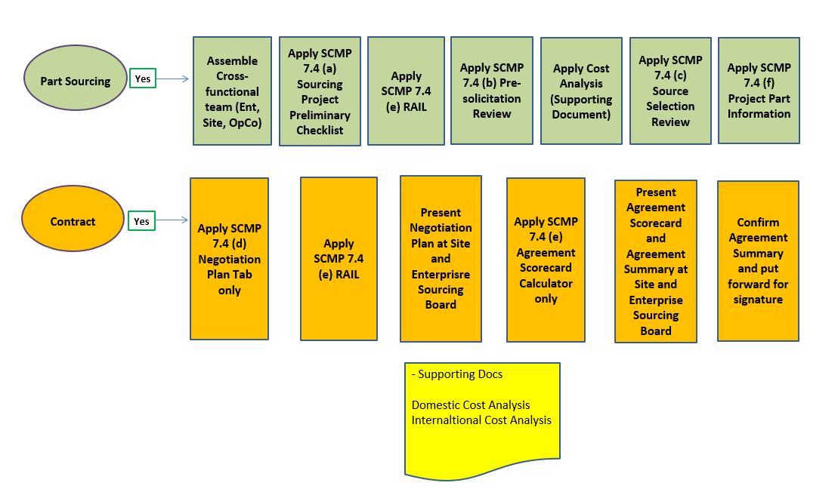

Required Forms

SCMP 7.4 (a) Sourcing Project Preliminary Checklist

SCMP 7.4 (b) Pre-solicitation Review

SCMP 7.4 (c) Source Selection Review

SCMP 7.4 (d) Negotiation Plan and Agreement Scorecard Calculator

SCMP 7.4 (e) Project RAIL

SCMP 7.4 (f) Project Part Information

Required Records

Document retention shall be in accordance with Triumph Procedure SCMP 1.1. Pertinent files, data and project execution information and should be retained at the individual project folder within the Enterprise Strategic Sourcing SharePoint site.

Revision History

Revision Level | Description of Change | Effective Date
Original | New Document | 01 September 2017
A | Removed reference to Forms 7.5 a & b | 20 November 2017
B | Added note to para. 2.1; revised AS9100 linkage reference | 15 December 2017
C | Document Revision/Forms Update | 04 October 2021
D | Document Revision/Forms Update | 01 September 2022
E | Document Revision/Forms Update | 01 June 2023

Approvals

/s/ Director Strategic Sourcing, Triumph XX XXXXXXX XXX

Attachment A
Sourcing Board (SB) Membership and Requirements
Exceptions
- PSR not required for Government/Customer Directed Source Procurements
- Raw/Shop material procurements of ≤$75K are not subject to SB process when procured from distributors
- Purchase Order releases pursuant to Agreements in force at time of release
- Nonproduction procurements, catalog items and services ≤$700K
- Software License or Maintenance Renewals if issued to provider of software equipment
- Spares and/or Out of Production requirements, or procurement from previous supplier of finished goods on the shelf

Table 1
Project Type/Scope | Buy/  Buy | Make/Buy | Buy/  Make
 | SR | SR | SR
Stakeholder Review
Project Lead | X | X | X
Site Purchasing Lead | X | X | X
Site Buyer | X | X | X
Work Transfer Lead | X | X | X
Supplier Development | X | X | X
Program Management | X | X | X

Table 2
Project Type/Scope | Buy/Buy |  | Make/Buy |  | Buy/Make |  | Contract | Contract
 | PSR | SSR | PSR | SSR | PSR | SSR | Neg Plan | Final
OpCo/Site SB
Site Finance |  | X |  | X |  | X
Site Engineering | X | X | X | X | X | X
Site Quality Manager | X | X | X | X | X | X
Site Operations |  |  | X | X | X | X
Site Purchasing Lead |  |  | X | X | X | X | X | X
Work Transfer Lead | X | X | X | X | X | X
Supplier Development | X | X | X | X | X
Program Manager/ Director | X | X | X | X | X | X
OpCo Supply Chain Director | X | X | X | X | X | X | X | X
Contracts Director |  |  |  |  |  |  | X | X
Site GM | X | X | X | X | X | X | X | X

NOTE: All OpCo/Site level approvals must be gained prior to conducting Enterprise SB activity.
Project Leader may add approvers on a case-by-case basis as deemed necessary
Highest OpCo/Site member in applicable role listed – authority may be delegated

Table 3
Project Type/Scope | Buy/Buy |  | Make/Buy |  | Buy/Make |  | ESA / Contract | ESA / Contract
 | PSR | SSR | PSR | SSR | PSR | SSR | Neg Plan | Final
Enterprise SB
Director Strategic Sourcing | X | X | X | X | X | X | X | X
VP Supply Chain | X | X | X | X | X | X | X | X

